Unit 6 Day 3

Today we are going to compare Duncan and Daria from our weekly story. If you can, read the story before you start today’s lesson.

Comparing Characters:

When we compare 2 characters, we think about how they are alike and how they are different. Let’s see how Duncan and Daria are alike and different.

What does Duncan like?

Duncan likes the small and quiet town.

What does Daria like?

Daria likes the big and loud city.

How are Duncan and Daria the same?

Duncan and Daria both like their communities.

Duncan and Daria are both happy that their sibling is happy.

Let’s put our comparisons into a Venn Diagram.

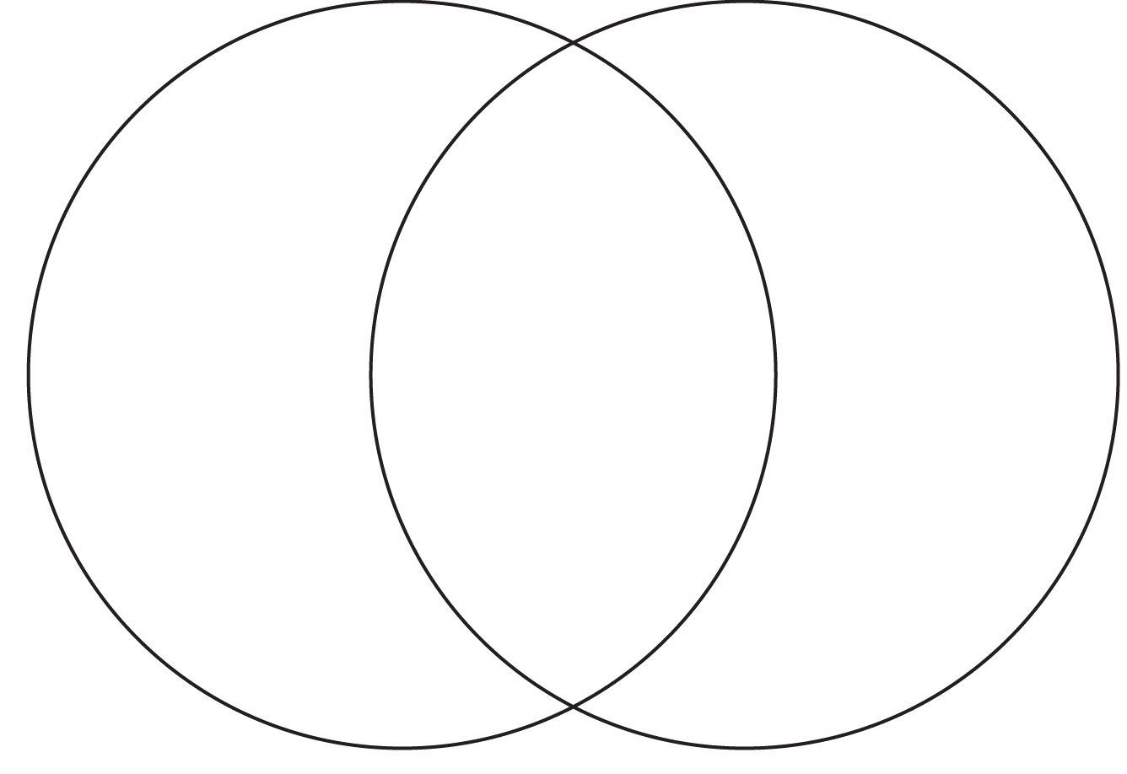 Duncan Daria

Alike

Duncan and Daria both like their communities.

Different

Duncan likes the small and quiet town he lives in.

Different

Daria likes the big and loud city she lives in.

When we fill out a Venn Diagram. We put the differences on the sides and how they are alike in the middle like it is shown above.

Activities! You are welcome to do all of these activities but please do at least three of them.

1. Have your child create a Venn Diagram and have them write 1 difference between Duncan and Daria and 1 similarity.
2. Have your child choose 2 things that are around the house and have them compare the 2 things. Try to have them tell you 2-3 differences and 1-2 similarities.
3. Have your child draw a picture of one place they visit often in their community. (school, library, park, store, etc.)

1. Have your child practice these simple sight words 5 times each (come, look, you, it, to). This means to say the word, have the child say the word, and write the word.